<https://docs.microsoft.com/en-us/azure/key-vault/key-vault-whatis>

<https://docs.microsoft.com/en-us/azure/key-vault/quick-create-portal>

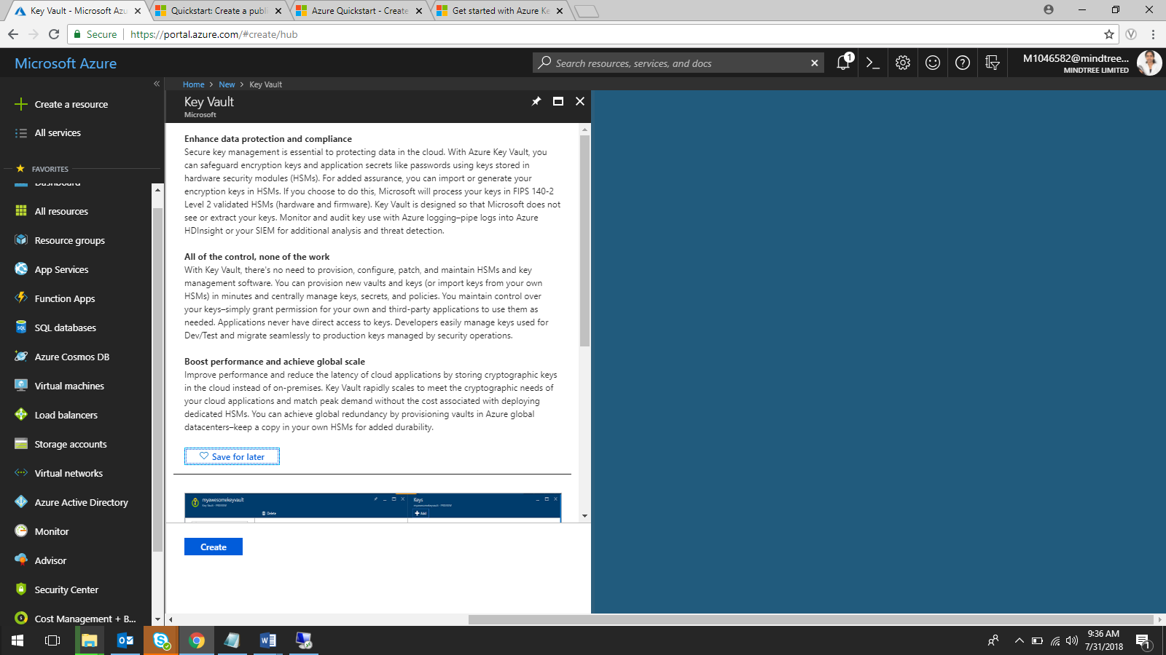

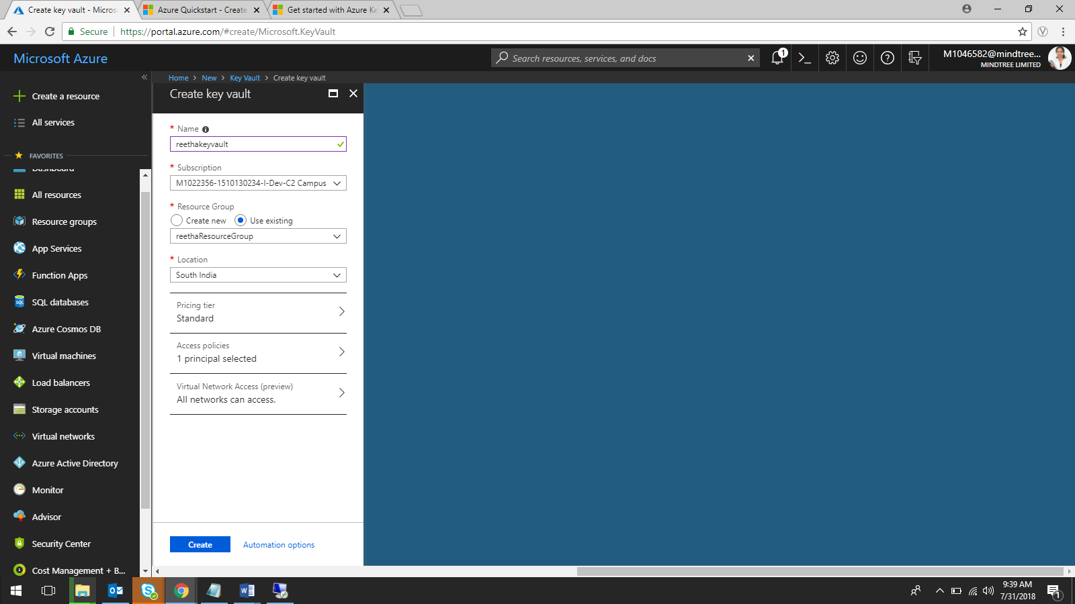

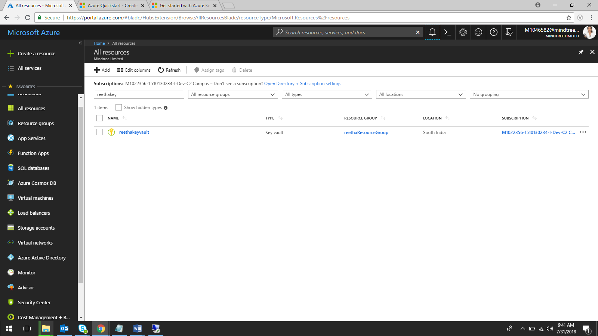

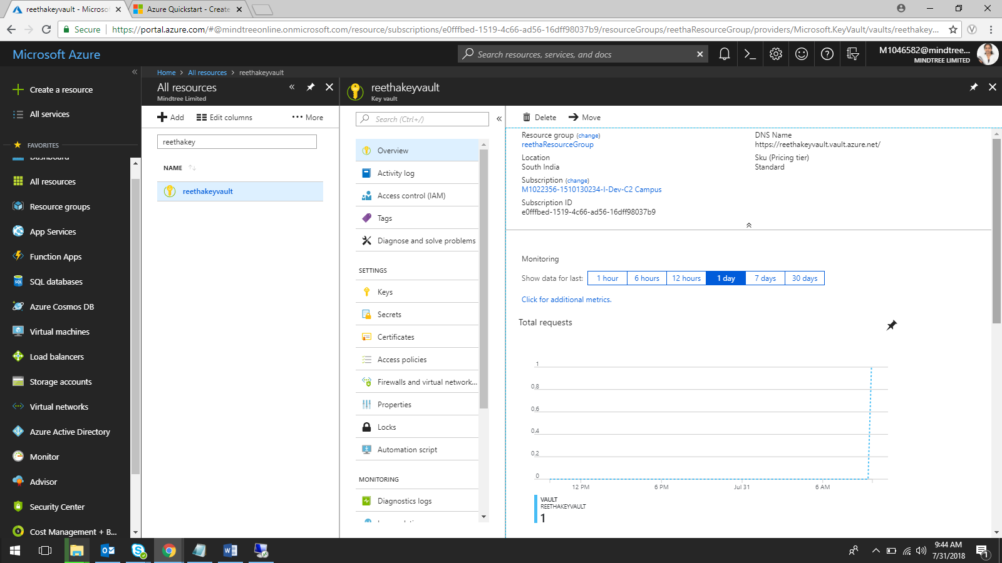

Vault Name: reethakeyvault

Vault URL: <https://reethakeyvault.vault.azure.net/>

**Add Secret to key vault:-**

Click on **secrets**

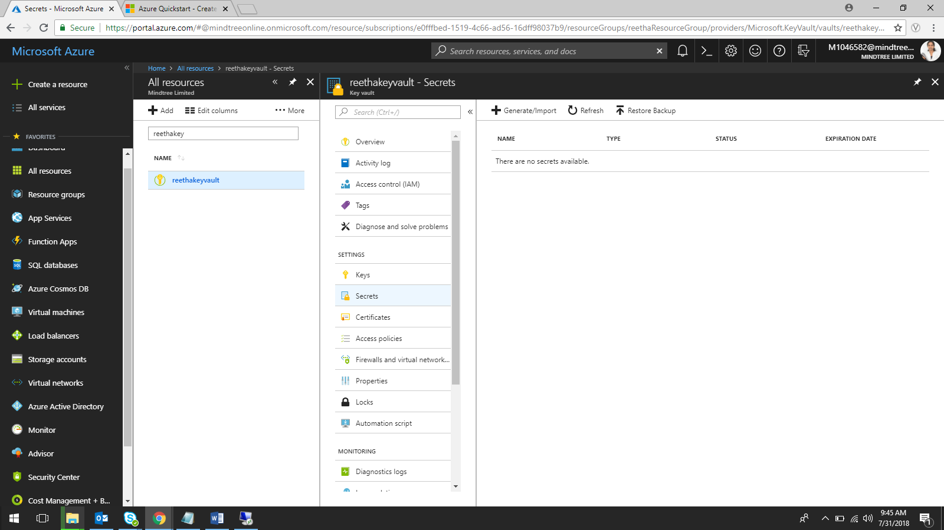

Click on **Generate/Import**

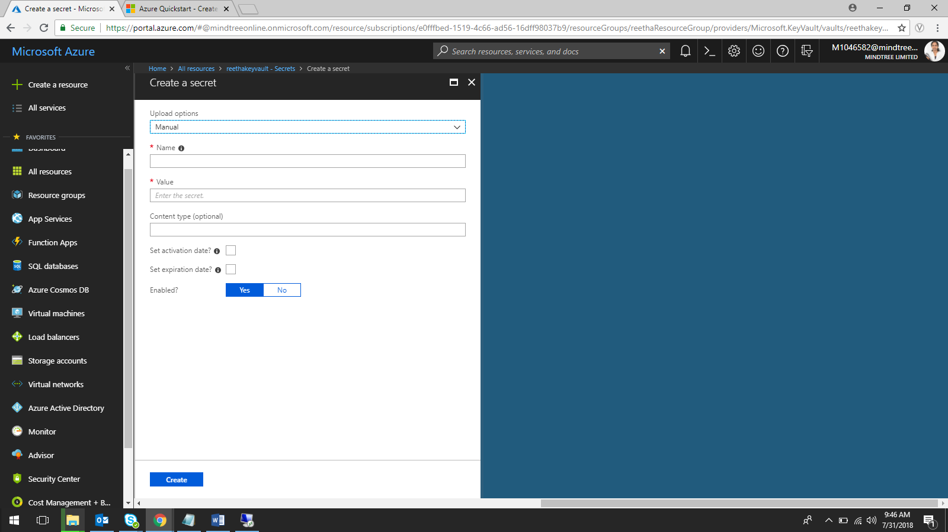

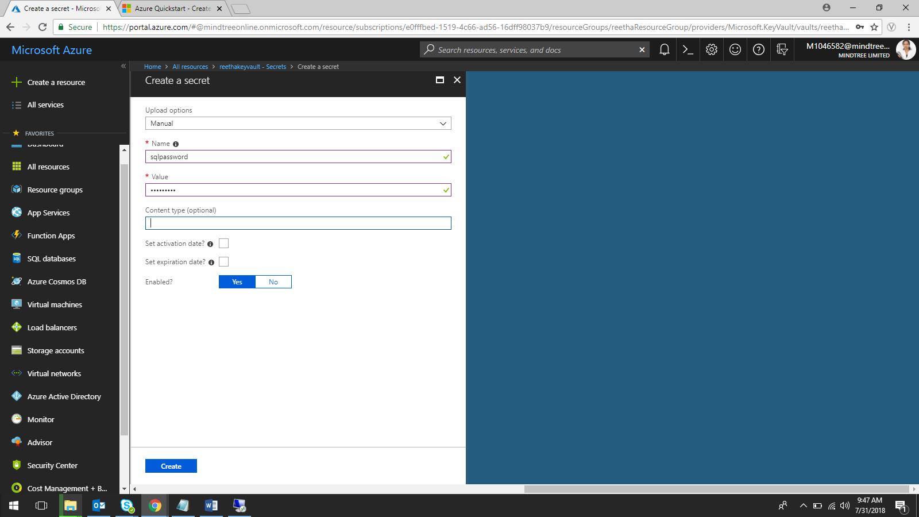

Here I’m protecting the sql password(2$Aqwerty) using the secret key sqlpassword

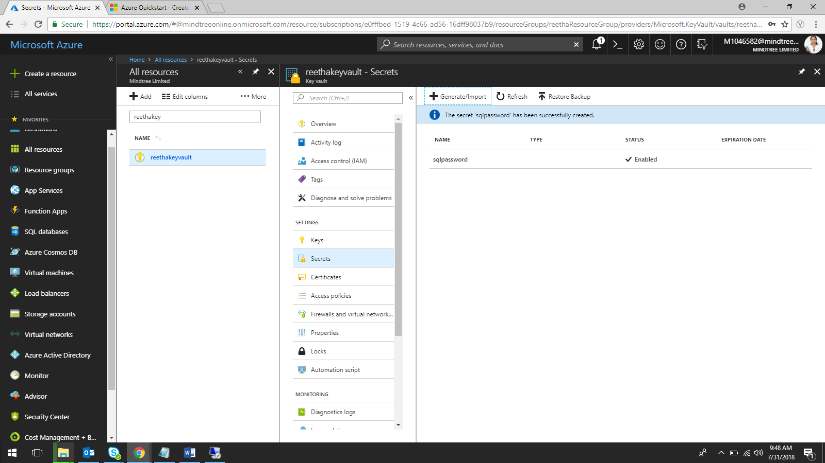

**Configure an Azure web application to read a secret from Key Vault**

Create a new .Net core Web application

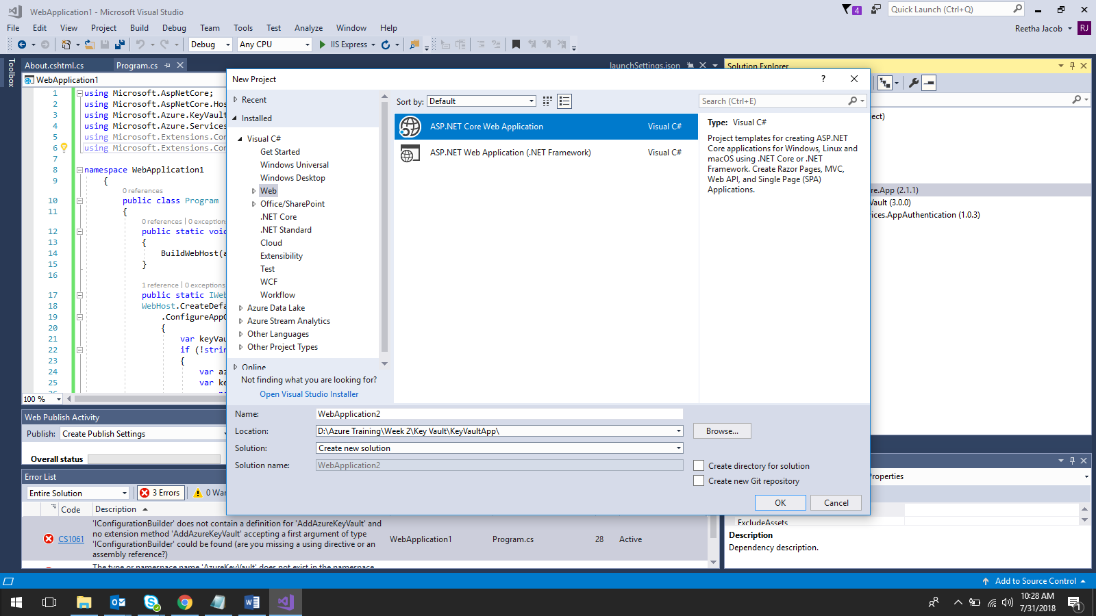

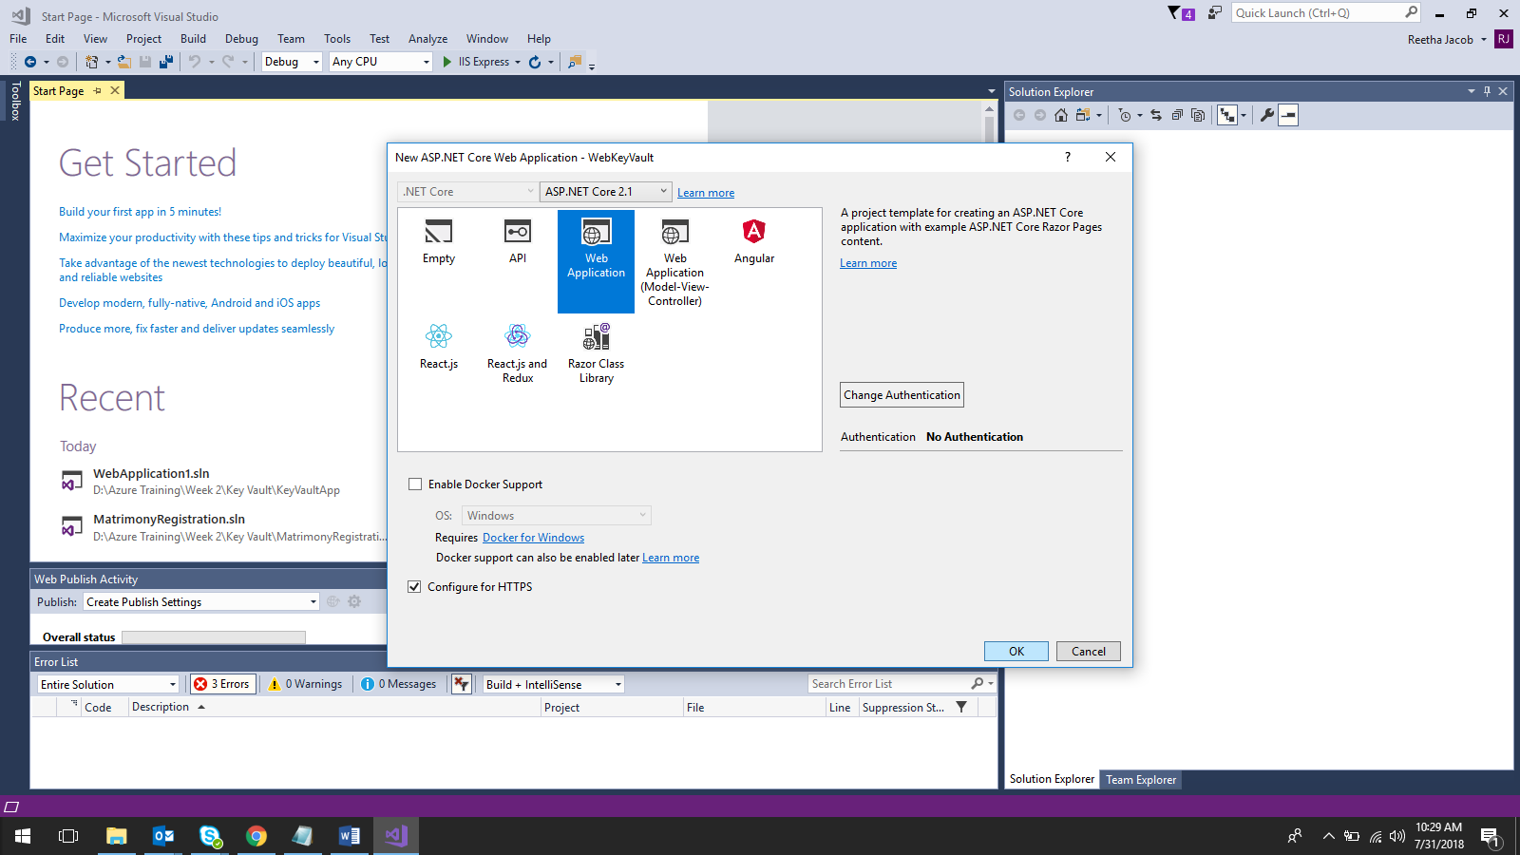

Install the below 2 packages using NuGet

1. [Microsoft.Azure.Services.AppAuthentication](https://www.nuget.org/packages/Microsoft.Azure.Services.AppAuthentication)
2. [Microsoft.Azure.KeyVault](https://www.nuget.org/packages/Microsoft.Azure.KeyVault)

App Path:- D:\Azure Training\Week 2\Key Vault\WebApplication2

